**Telecom Churn Analysis**

**Gaurav Singh**

**Pratyush Kumar Rath**

**Bikesh Kumar Maharana**

**Data science trainees,**

**Alma Better, Bangalore**

**Abstract:**

Customer trading is a major problem and one of the biggest concerns of large companies. Because of the direct impact on corporate income, especially in the telecommunications sector, companies want to develop predictive mechanisms in which customers are likely to enter. Therefore, finding the features that increase customer engagement is essential to take the necessary steps to minimize this confusion. A key contribution of our work is to develop a churn prediction model that helps callers to predict potential customers.

***Keywords : Python, Pandas,***

***Analysis, Churn Prediction***

***Employer Services.***

**1.Problem Statement**

In the telecommunications industry, customers are able to choose from multiple service providers and actively switch from one operator to another. In this highly competitive market, the telecommunications industry is experiencing an average of Churn between 15-25% per annum. Considering the fact that it costs 5-10 times more to find a new customer than an existing one, customer retention is now more important than customer acquisition.

For many potential users, keeping customers with high profits is the first goal of the business.

In order to reduce customer overcrowding, telecommunications companies need to predict which customers are most at risk of withdrawal.

In this project, you will analyze the customer data of a leading telecom firm, create predictable models to identify customers at high risk of extinction and identify key churn indicators.

**2. Introduction**

The telecommunications sector has become one of the largest industries in the developed world. Technological advancement and a growing number of users have increased the level of competition. Companies are working hard to survive in this competitive market based on a number of strategies. Three major strategies for generating additional revenue are proposed: - (a.) Acquiring new customers, (b.) Selling existing customers, and (c.) Extending the customer term. However, comparing these strategies by taking the amount of return on investment (RoI) per account showed that a third strategy is more profitable, proving that retaining an existing customer costs much less than getting a new one, moreover being considered much easier than a marketing strategy. In order to implement the third strategy, companies must reduce the power of customer exchange, known as "customer movement from one provider to another".

**3. METHEDOLOGY FOR CHURN SOLUTION:-**

In order to find a possible solution to the problem of churn prediction, that is, to effectively use the visualization method

for available data, one needs a deeper understanding of the corporate communications business rules and their specifications. Such information allows for the selection of attributes that are appropriate for the problem at hand. Data quality can be continuously improved by putting it under pre-processing.so for that

we put 3 phases for churn prediction.

**Understanding the Business :-**

This initial phase focuses on understanding the goals and requirements of the project from a telecom business perspective. The purpose of churn prediction is to identify the attributes that cause customer churn in order to prevent churn and retain customers. To do this, we look at the customers who have left and analyze the data for the period during which they continued touse the service of the telecommunication company.

**Understanding Data**:-

For the purposes of this project, a French telecommunications company shared data via CSV files exported from specific tables in a database. We anonymized the data (we looked at columns like churn, state, area code, etc.). The data received is for 12 months from January 1, 2018 to December 31, 2018 (approximately 133,400 records). Additional data on customer dissatisfaction is included in the dataset as it is a strong indicator of customer dissatisfaction.

**Data Preprocessing** :-

Data preprocessing involves careful selection of data attributes and records. Additional cleaning and data transformations are also performed as you are dealing with incomplete and noisy data. Data Cleanup used to remove unknown or null values, outliers, and invalid values ​​can negatively affect the performance of visualization when using raw data. The goals of data cleaning are to reduce the number of mismatched values, remove noise, and remove incomplete records and attributes. Since the data set is quite large, I removed all potentially problematic tuples. After that main phase start that is visualization and prediction.

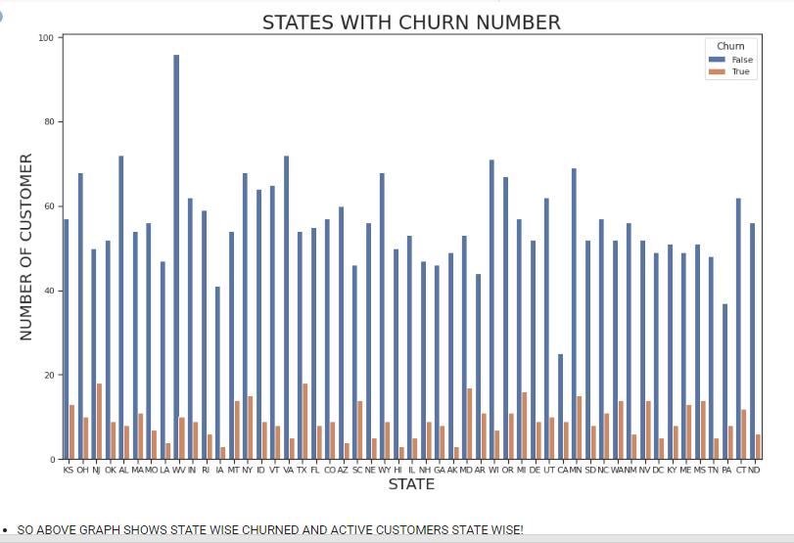

**4. Technology Used:**

* PYTHON
* PANDAS
* NUMPY
* VISUALIZATION
* MATPLOTLIB
* SEABORN

**5. Conclusion:**

The importance of this type of research in the telecommunications market to help companies make more profit. It has become known that churn forecast is one of the most important sources of revenue for telecommunications companies. Therefore, this study aims to create a system that predicts customer outrage in the Orange S.A. company.

After analyzing the test data in the data set, here is what we found in the data:

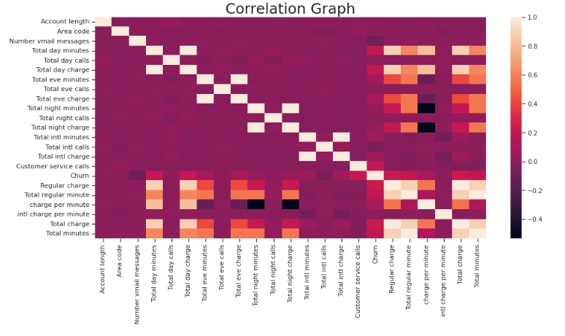

There are provinces where the churn level is high compared to others which may be due to low network coverage. * Account location and Account length do not play any role in the exchange rate, inefficient data columns * In the international system those customers with this system are widely used and international calling costs are also high so the customer has an unsatisfactory plan with network problems and high phone charges.

And on customer service call data indicates that whenever an unsatisfied customer calls the service center the churn level is high, meaning that the service center did not resolve the customer problem.

**6. References-**

1. W3SCHOOLS
2. GEEKS FOR GEEKS
3. ALMA BETTER
4. PANDAS DOCUMENTATION